**CODE DOCUMENTATION**

1. **Project Directory Structure:**

The code implemented for this project is in the *LARA* directory. In this directory you will find the *Makefile* that is used to compile and build this code. If the project has been built you will also see the object files (e.g. main.o), and the executable *prog.exe*.

The *src* directory contains the source files for this project, and the *include* directory includes the header files. The file *src/main.cpp* is used to test the classes implemented in this project. The main class in this project is the *LRR* class. The code for this class can be found in the *src/lara* directory. In *src/optimization* is an implementation of the *LBFGS* optimization algorithm (<https://en.wikipedia.org/wiki/Limited-memory_BFGS> for more information). The directories *src/utilities*  and *src/algebra* have some utility like functions used to perform frequently used calculations throughout the rest of the code.

To learn more about the theoretical aspects of the implemented functionality in this project I recommend reading the document titled *manual.pdf*.

1. **Building and Running:**

This code was developed on *Windows 10* and compiled using the *MINGW64* implementation of the *g++* compiler tools. There is no guarantee that this will work on other operating systems, but I would expect that it will work with any g++ version on any OS.

To build this code open a command prompt, go into the *LARA*, and run the command *make all*. Once the project has built you will see an executable named *prog.exe*.

To run this code, using that same command prompt window, type in the command *./prog.exe*.

1. **Testing the Code**

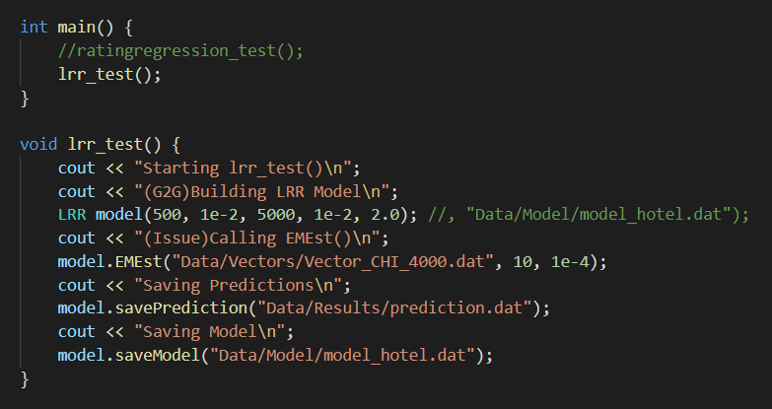There is a test function for the LRR functionality in the *main.cpp* folder (see image below). This function initializes the model with the same parameters used in the document *manual.pdf* which was provided by the original project implementation. Then this function calls the EMEst function passing a file of vectors, also from the original project. At the end of the EM estimation step, this function will save the predictions in *LARA/Data/Results/prediction.dat* and it will save the model, which can be loaded as a 5th parameter to the constructor, in *LARA/Data/Model/model_hotel.dat*.